

**Department of Computing**

**BS Computer Science**

**NASTP Institute of Information Technology**

**Submitted By:** Maisum abbas (023)

**Submitted To:** Sir Ibaad Babar

**Semester:** II

**Session:** Fall - 2024

**Subject:** Data Structures

**Date of submission:** 2 Oct 2025

**Lab Report 1**

**Task1:**

Using struct to make a simple structure and display data as display function

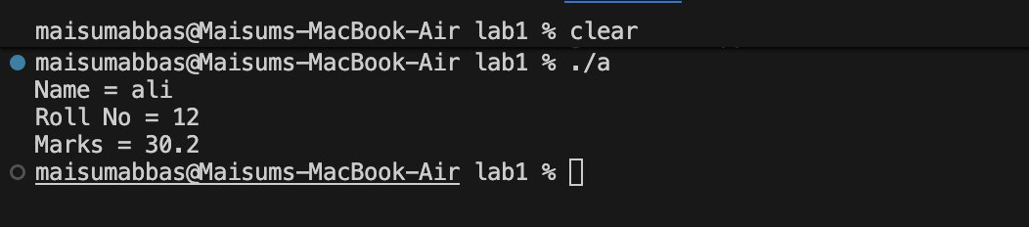

**Task2:**

Using constructor in class to automatically initialize the variable and display to user

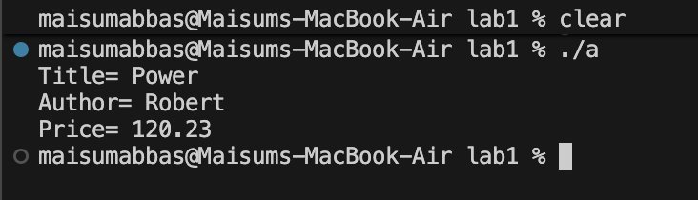

**Task3:**

Created 3 objects and display on the output data is given at the time of object creation

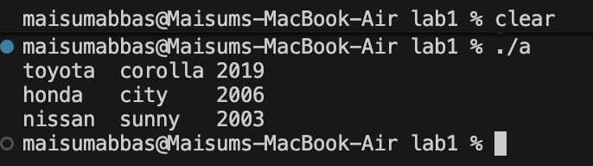

**Task4:**

Using the for loop and some logic if and else created the hollow rectangle and the area and perimeter function was easily created

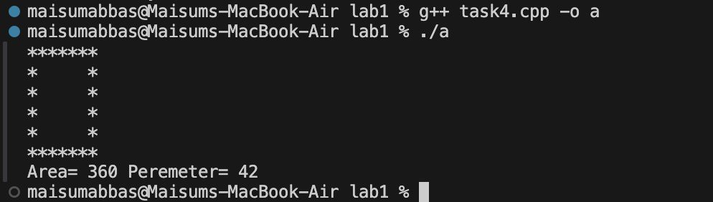

**Task5:**

Using iteration we make multiple object by just changing one number. After that the object list is given to the function and then function like average and min and max was the implemented to the data that is in the hand

